LAB TASK-5

Implementation the following operations: enqueue, dequeue and finding an element:

1. **Linear Queue using arrays**



OUTPUT:

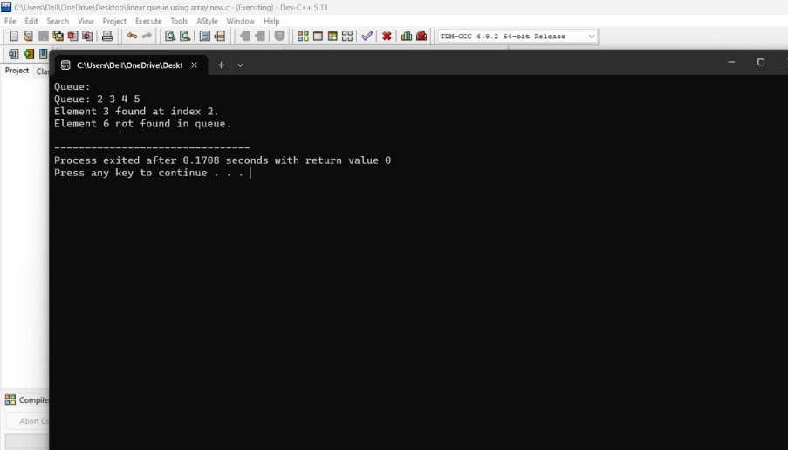

1. **Circular queue using arrays**



OUTPUT:

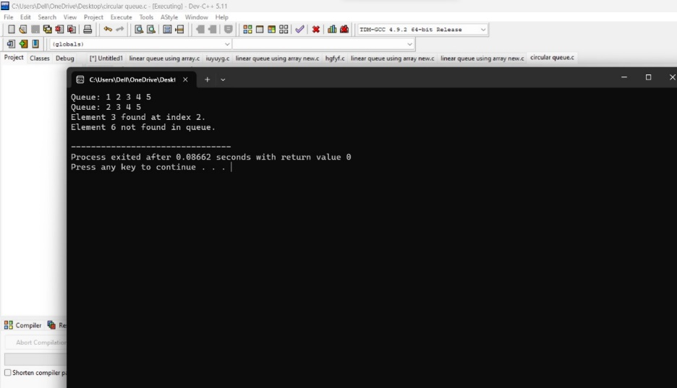

ASSIGNMENT-2:

The “*4-Queens Problem*” consists ofplacing four queens on a 4 x 4chessboard so that no two queens can capture each other. That is, no two queens are allowed to be placed on the same row, the same column or the same diagonal (both primary and secondary diagonals). Write a C program to simulate the given problem and perform the algorithmic complexity analysis for the solution you propose.



OUTPUT:

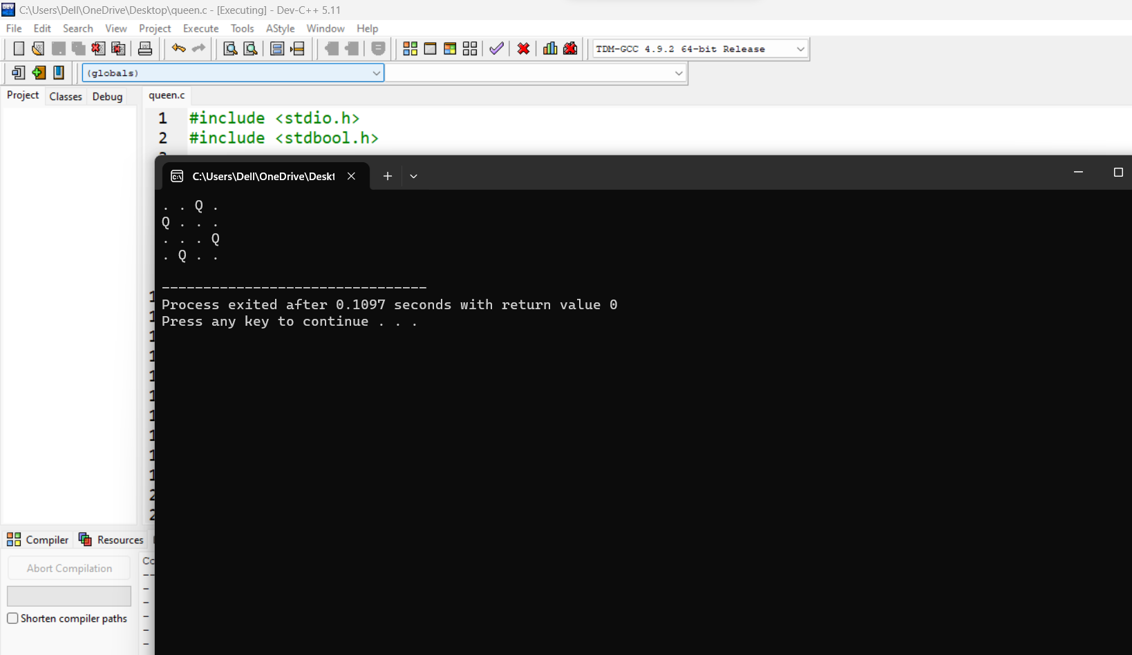

**THE END**